

**Object Oriented Programming Lab Project Report Course Code: CSE215**

**Project Name: Burger and Coffee Management System**

Group Members:

171-15-8596 Rashidul Hasan Hridoy

171-15-8597 Mudakherunnessa Monisha

**Submitted To,**

**Anup Majumder**

**Lecturer, Dept. of CSE,**

**Daffodil International University**

**Date of Submission: 14 April 2018**

**Some Image of our application:**

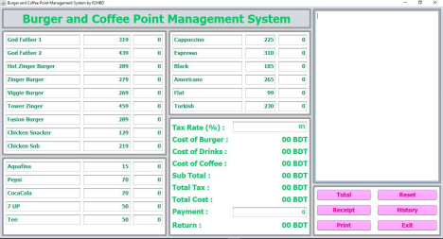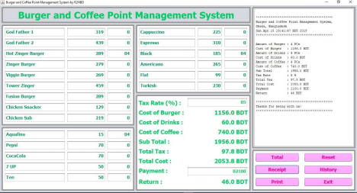

**Image of PDF Bill Copy:**

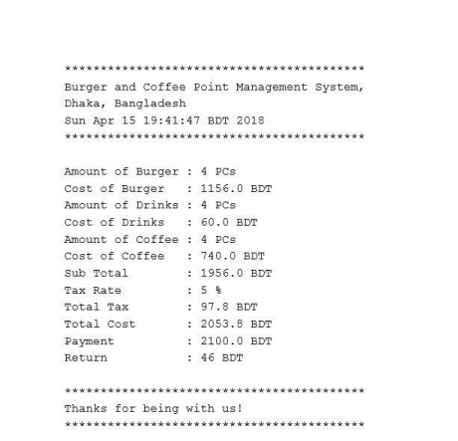

**Reset and History Button Work’s Example:**

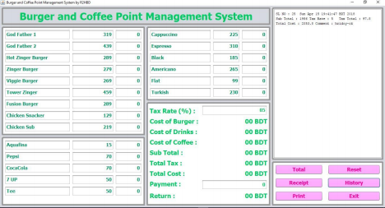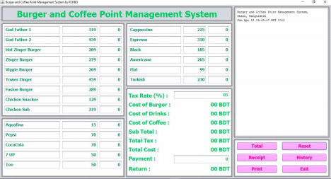

**Image of Database Table:**

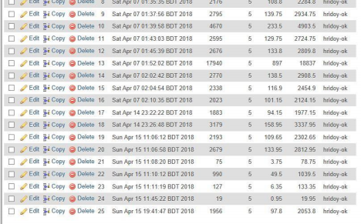**Introduction:**

• Our topic is very important because it’s a real-life project and we can easily implement it at any restaurant and we will customize our project as our users need.

• Our application is mainly used for Restaurant to save their time and money. User can easily maintain his or her restaurant easily without facing problem.

• We think we will help our users by saving their time.

Background:

• It is desktop application and user need Windows 10 32 or 64-bit OS system and a printer.

• It is different and better from other because it’s need low storage space. Application size is also very low.

**Project:**

• Owner or manager faces many difficulties when he or she run a restaurant. They need to keep a large number of cost data. They need calculator to calculate cost and paper to write them. We developed our system to solve all this problem.

• Using Java Swing we developed this application, and it will help user to maintain all daily works.

• We used many JFrame design components to design the application. We tried our best to create a best interface for our application. It will help our customer’s very much.

• User can change product name, price, tax rate and many other things. User can count all types of cost separately. It will print a pdf type bill copy. We use database to record all our data about cost like cost and tax.

**Summary:**

• It’s a desktop-based application using Java language.

• First, we collected problems that faced by restaurant owner or manager. Then we discuss about the problem and find it’s solution.

• Secondly, we create a blue print of our application and started working on it. We design our application by JFrame.

• Thirdly, we write codes to solve problem. We also connect it to database. Then we run our application and fixed our bugs.

• Finally, we finished our project.

**Conclusions:**

• While working on this project, we learned many things like how to solve real life problem, create a module of work plan, team discussion to solve our project as early possible.

• We worked to decrees application size and we are done it. We create a strong database to save all data.

• We think our application will help our customer and we will give then strong support.

• Our future plan is to develop android and web version of this application.